PIF Interim Presentation 2nd semester
By: Zaslavskyi Dmytro


Table of Contents:
- Sensors 2 – brightness and barometric sensors…3
- Web Database Server…8
- Assembly…25
- Data Transfer...31
- Lighting…36
- Backup…43

PIF – Sensors 2
By: Zaslavskyi Dmytro
Table of contents:
- Item List
- Soldering
- Results
- Conclusion

List of Items:
The list of items for this sprint includes:
1x Barometric Sensor,
1x Light Sensor,
1x 4 pin adapter with wiring,
1x 6 pin adapter with wiring,
1x Raspberry Pi with PCB board attached to it and a screen,
1x Soldering station.

Soldering:
To solder together the light sensor, I have used 4 pin connector with wiring. Following the document’s guide on the socket connection, I checked the wiring colors and connected them to the corresponding sockets
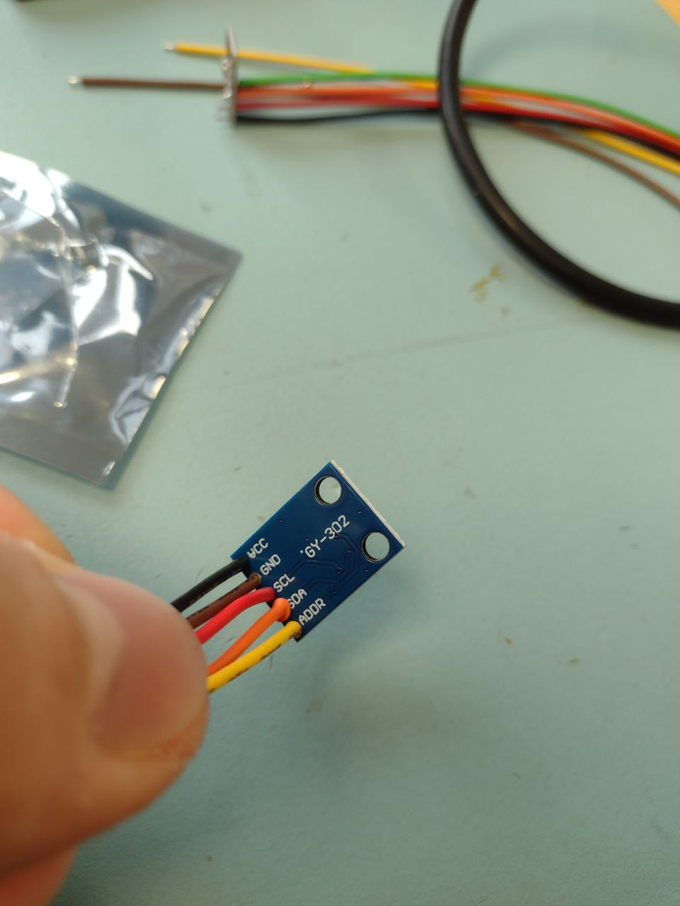
After that I did the same with the gas sensor, but the document has shown that 2 other wires should remain disconnected from the gas sensor.
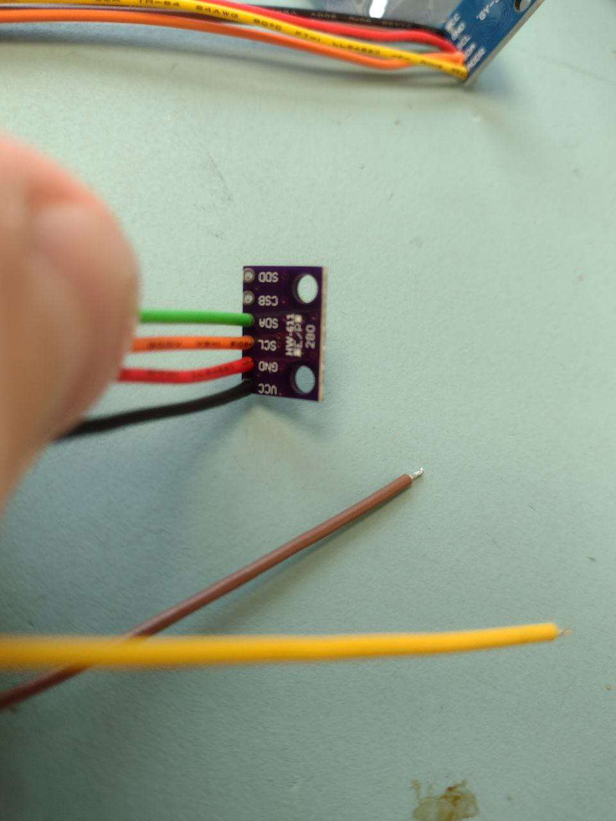

Results:
This is the following result that I have received. Unfortunately, due to the lack of time we could not properly check whether the sensors worked.
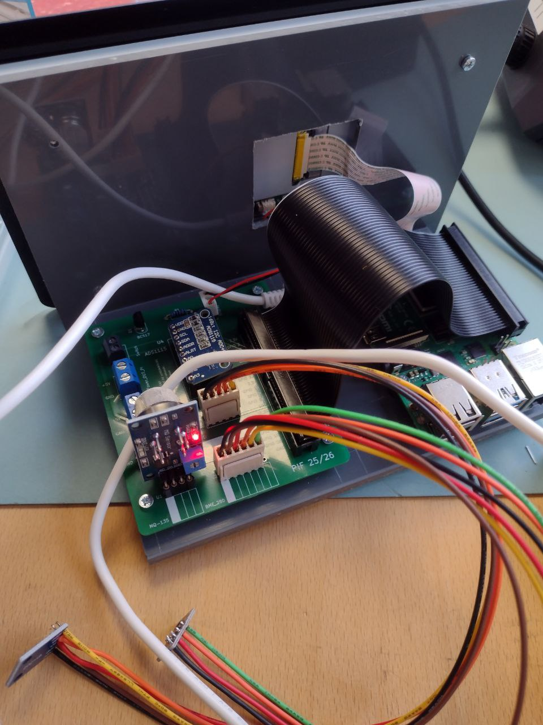

Conclusion:
The main real problem in the task was to correctly identify the arrangement of cabling, in order to allow me to solder correct sockets on the sensors. Because we did not have time to work on our raspberry pi and check its functionality I will have to do it later, without inclusion to the report.

Userstory A4 – Web Database Server
By: Zaslavskyi Dmytro



Table of Contents:
- Introduction. pg 3
- Installation of Apache 2, PHP, assigning permissions to folders,configuration and deployment of the virtualhost. pg 4-6
- Installation of mysql-server, mysqli_secure_installation, creation of management users for phpMyAdmin. pg 7-8
- Installation of phpMyAdmin, configuration and connection to mysql-server. pg 9-12
- Deployment of the database and website. pg 13
- Setup of a self-signed sertificate(SSL). pg 14-16
- Conclusion. pg 17

- Introduction:
This documentation includes the necessary configuration steps to set up a web-database server on the Ubuntu Desktop Operative System that distributes the website to the users and allows administrators to

- Installation of Apache 2, PHP, assigning permissions to folders,configuration and deployment of the virtualhost:
To install apache2 and php, I used sudo apt install apache2 libapache2-mod-php. This allows to immediately install apache2.service with php module installed and enabled enabled. Check the installation with sudo systemctl status apache2. This allows us to check if the service is running.
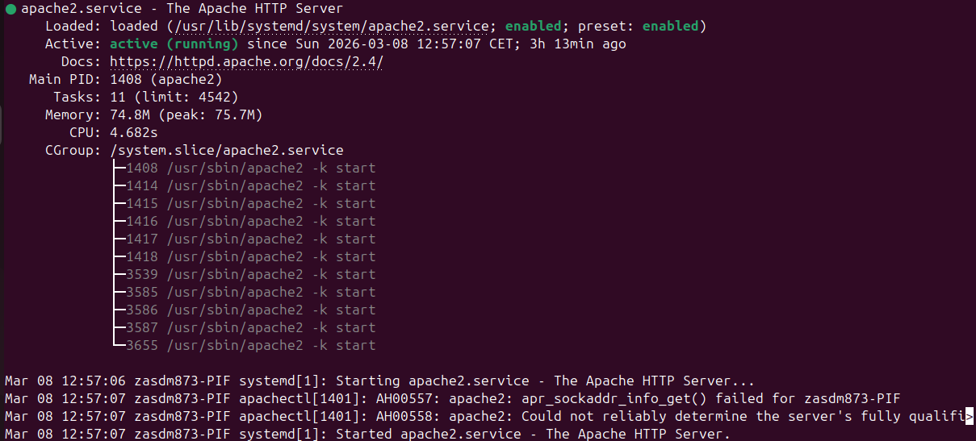
Installation is successful. That means that we can proceed to the next step. Next we need to create a directory for our website. This is why we run sudo mkdir /var/www/PIF. After creating directory called PIF at /var/www – we use cd /var/www and there we use sudo chown www-data:www-data PIF && sudo chmod 755 PIF. Running this command set(marked by “&&” that means AND) will change the ownership of PIF folder to www-data of group www-data(user and group created by Apache2) and change the permissions to read-write-execute for the owner, read-execute for group members, read-execute for other users. Then we run ls -la to see the owner and permissions of the directory PIF.
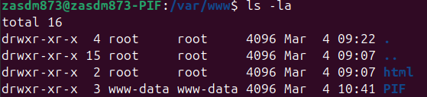
Success. Now, we must create and enable new website by creating a virtualhost. To do this we use sudo nano /etc/apache2/sites-available/pif.conf. This will start writing(with “nano” console text editor) file called pif.conf in the directory of /etc/apache2/sites-available where all configurations are set, in the /apache2/sites-enabled are only running configurations. In pif.conf we write the following configurations:
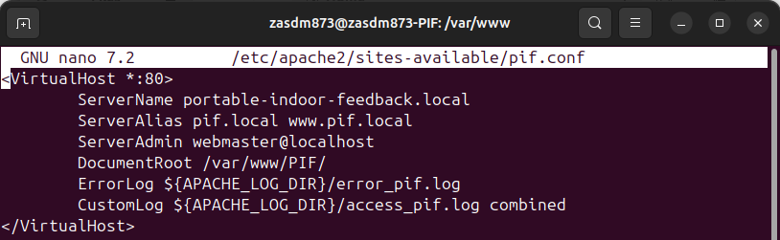
<VirtualHost *:80> tells to create a virtual host listening to any port and respond with port 80. Servername assigns the website a permanent name that is recognized by apache2. ServerAlias creates addintional names that are recognized by apache2 and will redirect it to the ServerName. ServerAdmin defines the email address the server includes in error messages and server-generated documents sent to clients. DocumentRoot defines the directory from which Virtualhost will upload the website. ErrorLog and CustomLog will be used to assign log files for our webserver in order to streamline the maintenance. After creating the config we save it and before enabling it we use sudo apache2 configtest that will run all our configuration files and test for any errors.
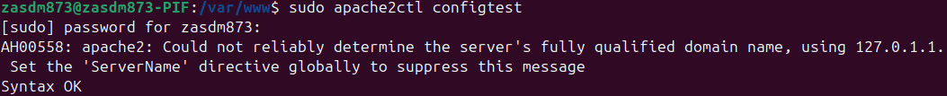
Syntax test has returned okay. So next we use sudo a2ensite pif.conf to deploy our website and then we use sudo systemctl reload apache2 to update the service. In this case we use reload because it will allow to not have any downtime in the server work, though restart can be used for the same purpose. To access our webpages later I have edited file /etc/hosts with sudo nano /etc/hosts/ where I have added my server alias to the list of the hosts, which will allow me to access my website later.
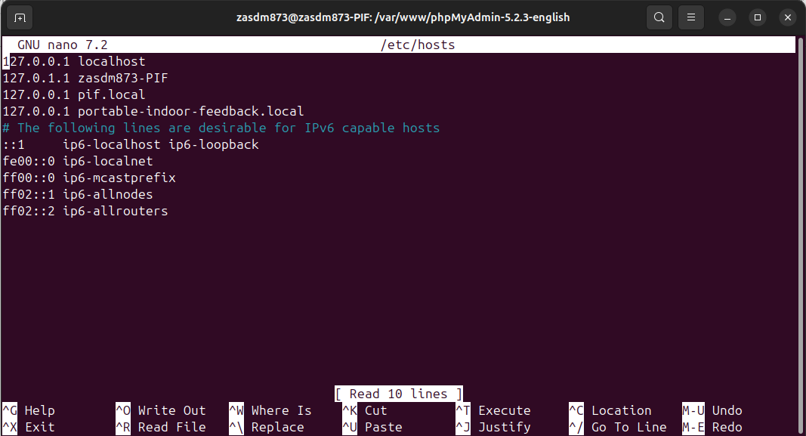

- Installation of mysql-server, mysql_secure_installation, creation of administrator user for phpMyAdmin:
To install mysql-server I used command sudo apt install mysql-server. After the installation of the mysql I ran sudo systemctl status mysql to check if the installation is correct.
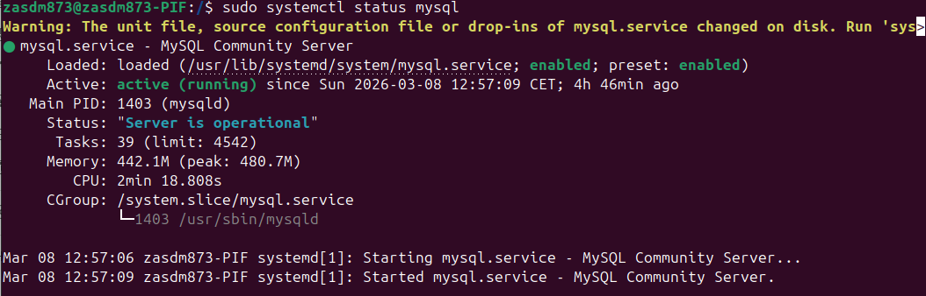
Then, I ran sudo mysql and created an admin user for future phpMyAdmin installation using sql code CREATE USER ‘admin’@‘localhost’ IDENTIFIED BY ‘PIF2026admin’; GRANT ALL PRIVILEGES ON *.* TO ‘admin’@‘localhost’ WITH GRANT OPTION; - this command will create additional administrator user that will be able to access and manage phpMyAdmin after installation and configuration. Then I proceeded to run sudo mysql_secure_installation. After running the command it deployed several prompts:
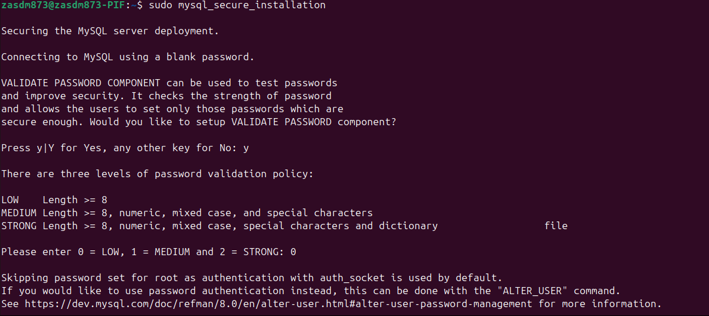
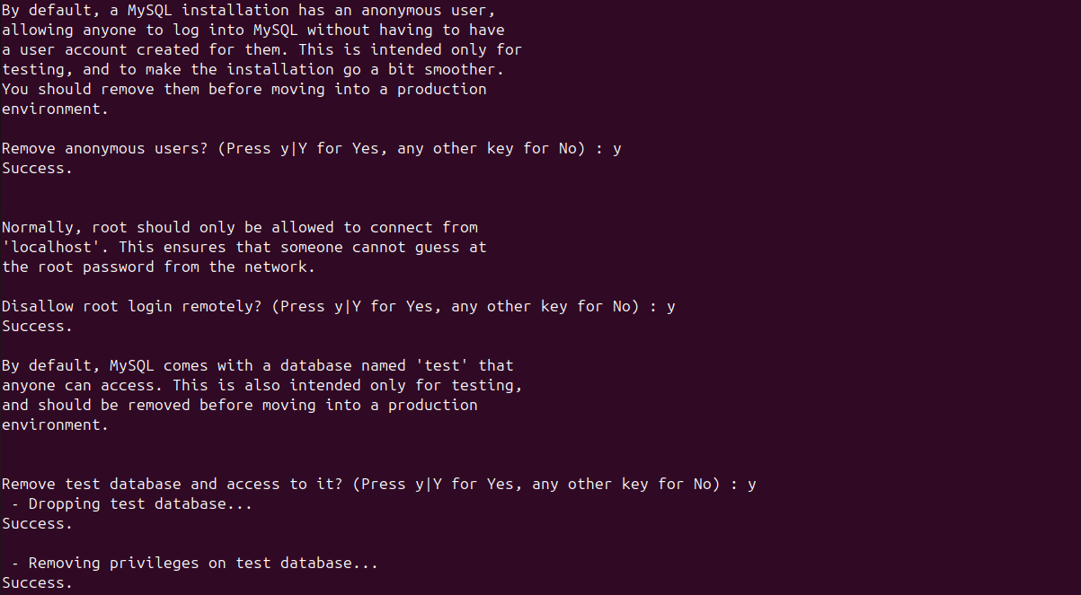
Those prompts have provided password validation, removed anonymous users(that could lead to a vulnerability in the mysql-server), disallowed remote login with root, removed test database(that could lead to a vulnerability in the system) and reloaded privileges to confirm the changes.

- Installation of phpMyAdmin, configuration and connection to mysql-server:
To install phpMyAdmin I have went for the official website where I downloaded a .tar file of phpMyAdmin 5.2.3
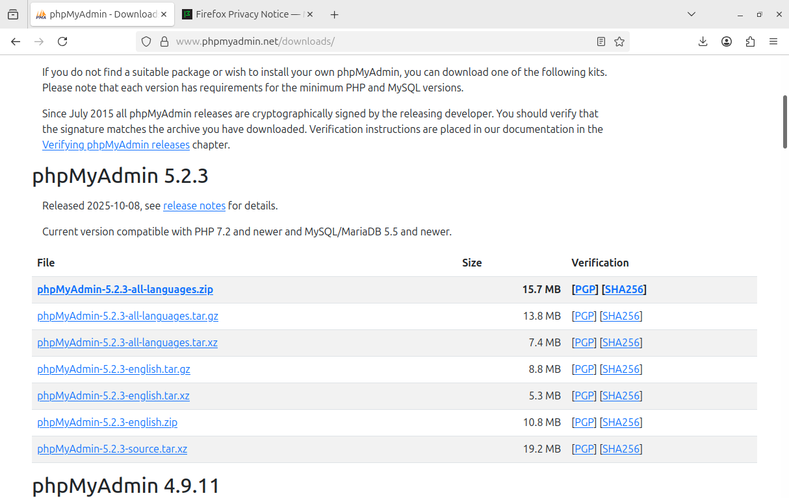
Then, I unpacked the file and moved it into the PIF directory with sudo cp -r ~/Downloads/phpMyAdmin-5.2.3-english /var/www/PIF
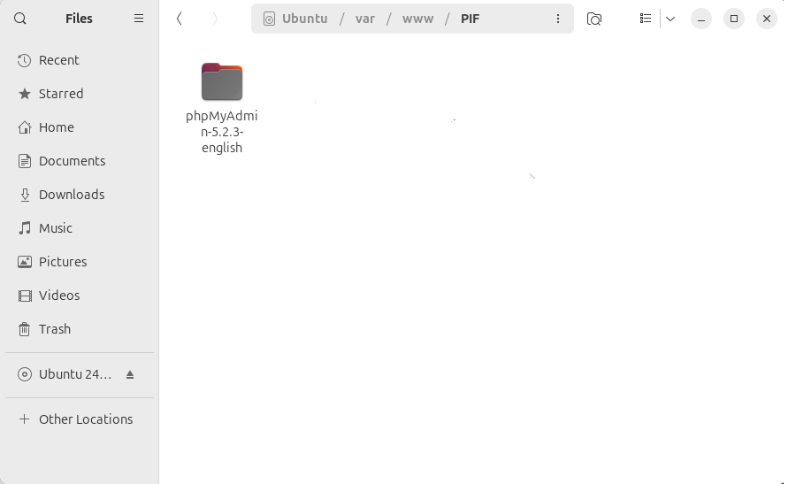
Then I have renamed it with sudo mv phpMyAdmin-5.2.3-english phpmyadmin to have easier access to it. Inside the phpmyadmin directory I have renamed file config.sample.inc.php to config.inc.php with sudo mv config.sample.inc.php config.inc.php to provide it with base configuration file.
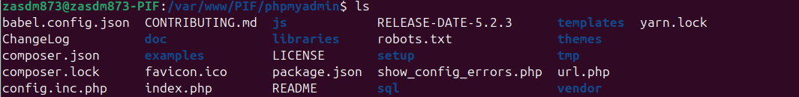
Then, I have installed mysqli extension for php with sudo apt install php8.3-mysqli to allow my webpages to run and support phpmyadmin. Now test if phpmyadmin works
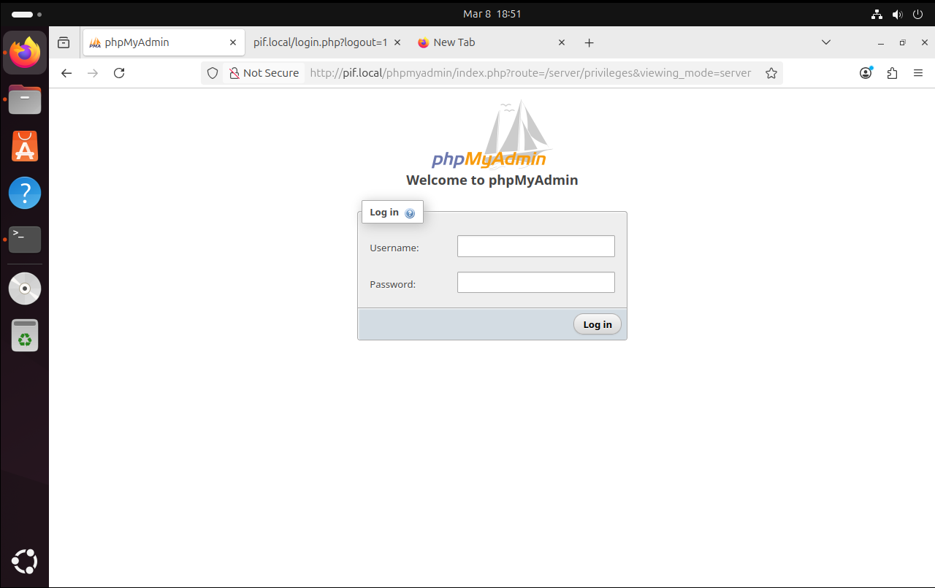
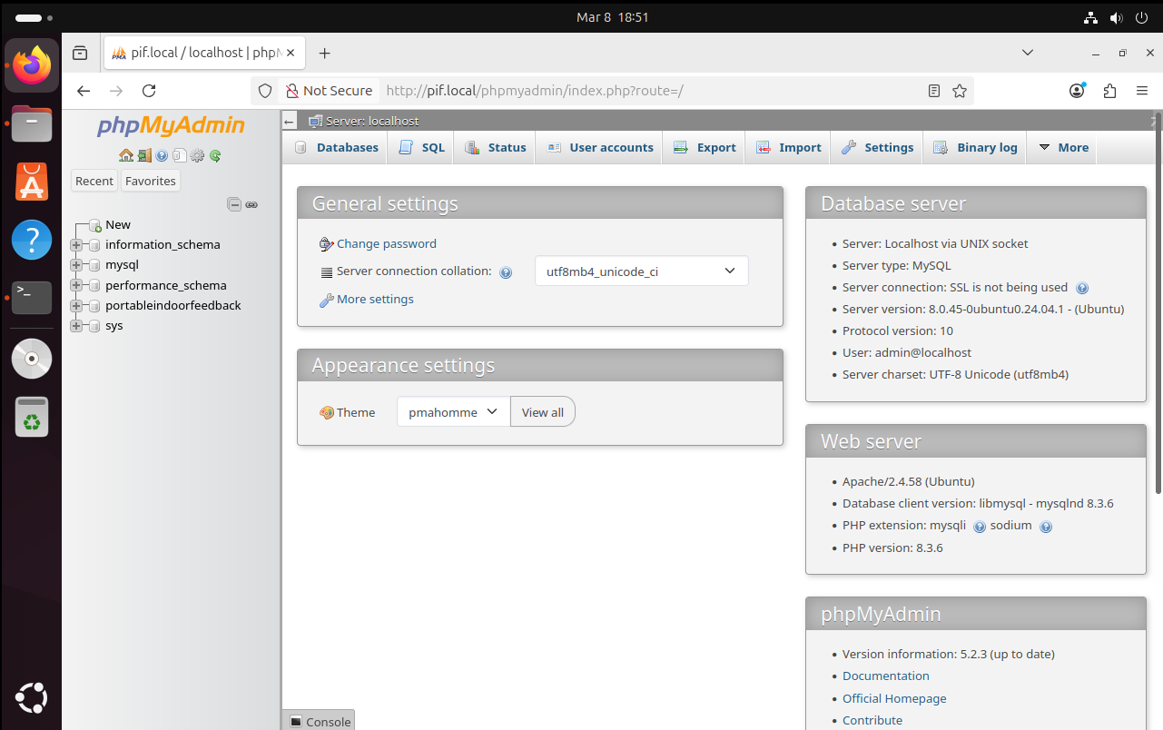
After confirmation of phpmyadmin working. We can now create a new database user for our webserver.
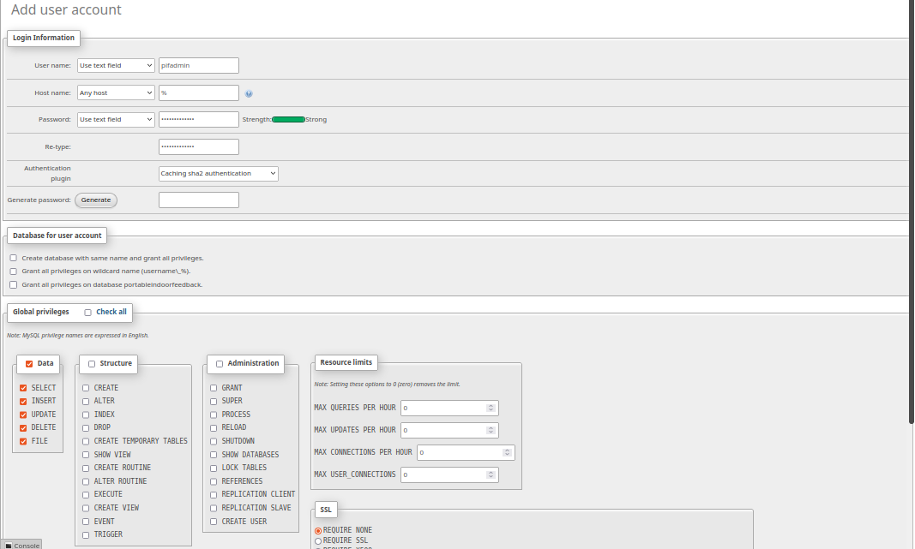
Current website only requires a managing user that can manipulate data.

- Deployment of the website and database:
To upload my website and database, as a test I have used my past solutions for previous sprints. I adjusted the configuration to use my new database user and uploaded database sql.
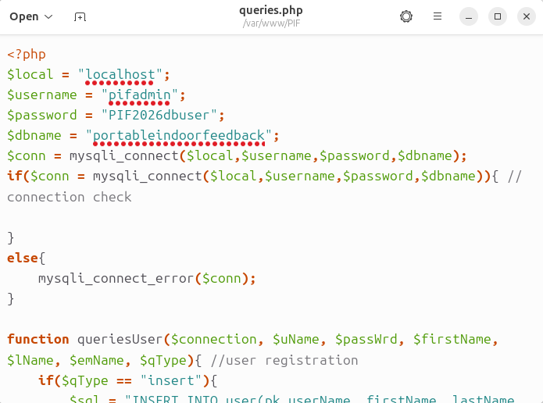

- Creation of a self-signed certificate:
In this section I will create a self-signed certificate for the web-database server. To prepare for the key deployment, we need to open /etc/ssl and create new folder to contain the certificates called PIF_keys.
Firstly we need to generate an rsa key. We use sudo openssl gebrsa -out pif.local.key 2048. Then, we need to create a certificate with sudo openssl req -x509 -new -nodes -key pif.local.key -sha256 -days 365 -out pif.local.crt. In this command req means certificate request, x509 output a certificate instead of a csr file that needs to be signed. After this a series of prompts will pop-up:
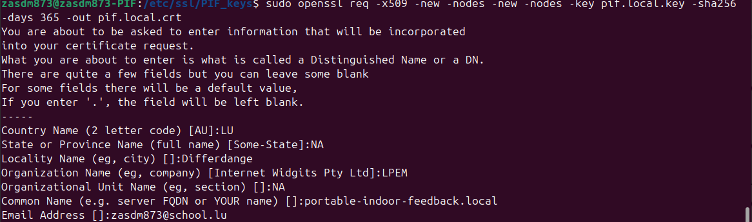
Those prompts request information for certificate. After that, we have to enable ssl in apache2 with a2enmod ssl. That is used to enable modules of apache2. After enabling ssl, we need to configure a new virtualhost and deploy it. The configuration for new virtualhost is as follows:
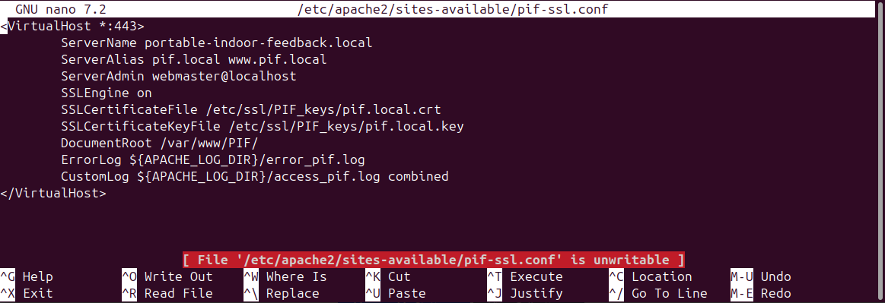
The only thing added is the SSLEngine – SSLCerificateFile and SSLCertificateKeyFile that enable usage of ssl and select the ssl certificate that is used to represent the website. After that we setup the redirect in old pif.conf:
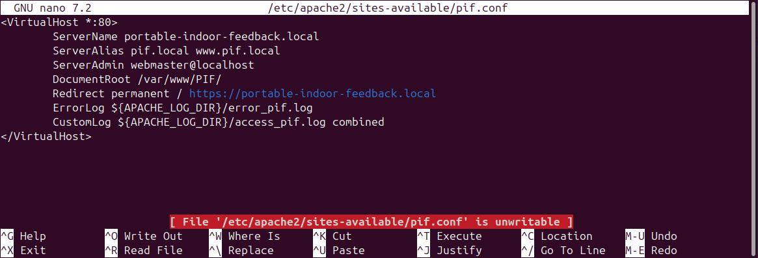
We add new line Redirect permanent with reference to https version of the website in order to avoid leaving vulnerable access to the webserver. After that we test the certificate: 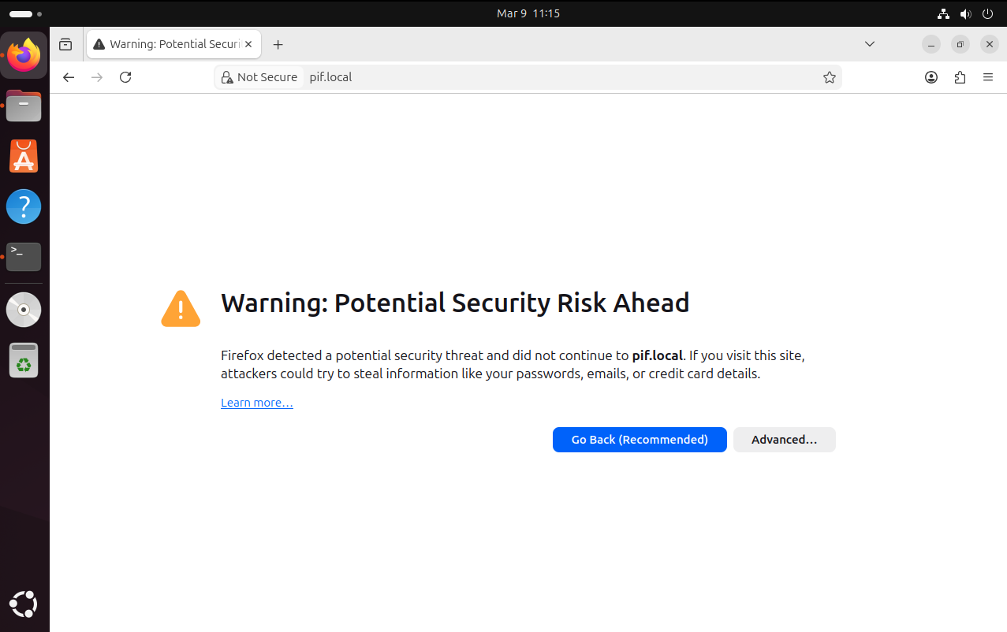
We got a warning, that means that our self-signed certificate work because browser recognizes our certificate as self signed.
- Conclusion:
In the end of this documentation we get a working web-database server that can provide website access to other users. It is reinforced with database users that have restricted access, secure installation of mysql-server and supports https port that encrypts traffic – making sniffing less likely.
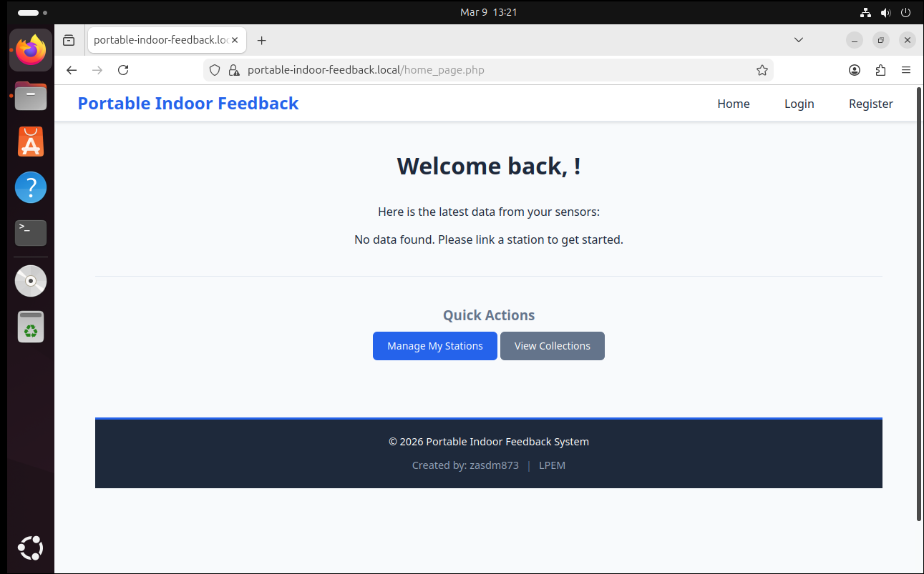

Userstory A6 – Assembly
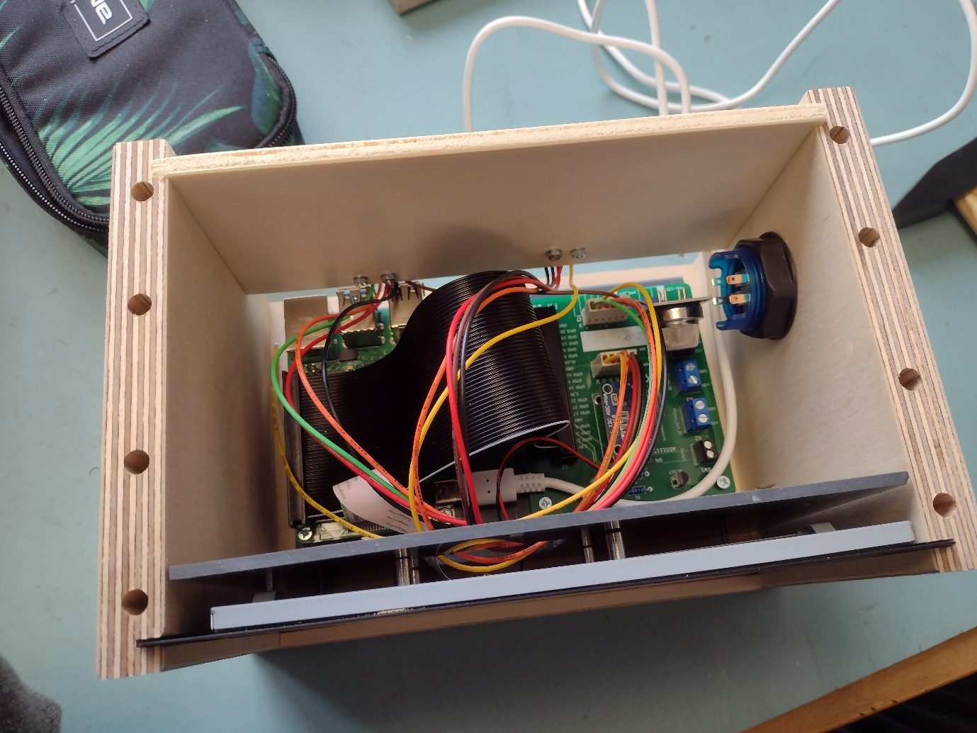

Table of contents:
- Introduction
- Holes
- Assembling
- Result
Introduction:
In this document will be described steps that were taken to assemble the container for the Raspberrypi. Item list included
1x platform for the container
2x walls of the container (left and right)
1x back cover
1x roof
1x button


2. Holes:
Before assembling the container, we had to make some modifications to its walls. In the project documentation it was said that the walls have to have 1 hole for the button that is ~30mm in diameter and to have 1 hole for the LED wiring that is ~ 2.5mm in diameter. As the drilling stations were already prepared, the only thing that we had to do was to begin drilling.
Result(does not capture the LED wiring hole yet):

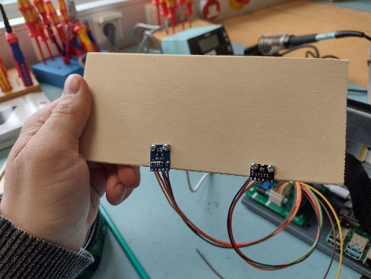
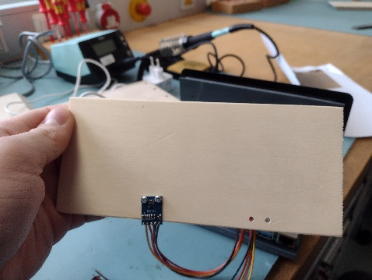
We also had to drill holes on the back plate, to allow us to let sensors hang out of the box to take measurements of the environment.

3. Assembly:
The container’s parts already had predetermined holes drilled into it that allowed for a swift assembly; to connect platform and walls, we had to use hammer and dowels to connect the platform and walls. Then in the premade opening we slotted the backplate.
4. Result:


Userstory L5 – Data transfer
Table of Contents:
- Introduction
- Task achievement
- Results
- Introduction:
In this documentation will be included all the necessary steps to enable data transfer from Raspberry Pi to the webserver.

- Task achievement:
To complete the task, first thing I had to do was to open config.toml file and change the ip with destination to the appropriate one in the server.
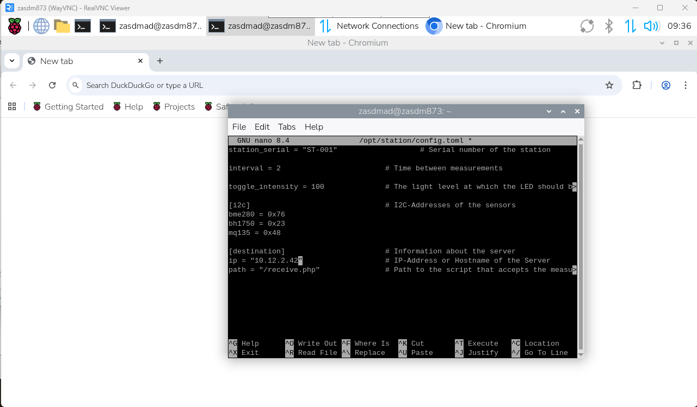
After that I had to create and upload receive.php on my webserver, that would process by taking it from the POST request and inserting it into the database.
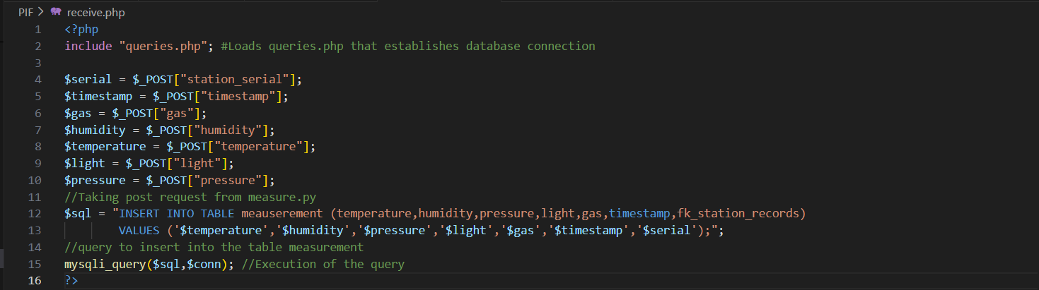
Receive.php gets post requests sent by measure.py, then takes them as variables from superglobal array $_POST[“”] and then runs a sql script that is responsible for inserting data into the database.
Because my webserver is set on the virtual machine, I had to change the network settings and put it on the bridged connection, otherwise raspberry pi could not communicate with the webserver.

When I tried to run measure.py to test if the sending data works, it has shown me that python post request is being refused because the SSL certificate is self-signed. To fix it, I took down the https version of the website and when attempting to connect to the http version it did work.

3. Results:
In the end, raspberry pi was able to upload measurements to the web database server.
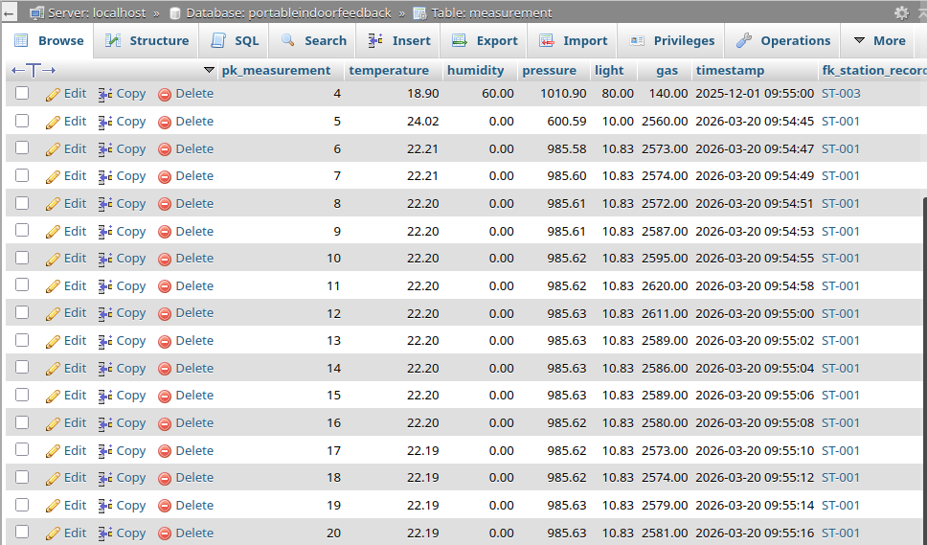

PIF – Userstory A7
Table of Contents:
- Introduction
- Attaching the button
- Attaching the LED strip
- Result

- Introduction:
In this userstory, I have attached a button that should power the LED lights and the LED lights.
List of equipment:
2x black wires
2x red wires
1x Soldering station
1x Roll of two-sided tape
2x Shrinking tube

- Attaching the button:
First I have soldered the black and red wires to the button, then I covered them with shrinking tube.
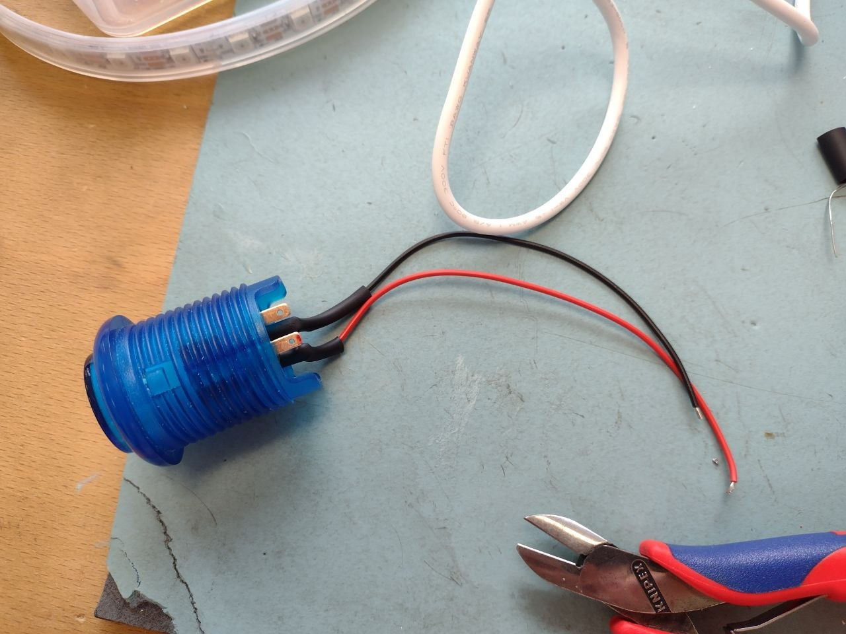
Then I slotted it in the printed circuit board.
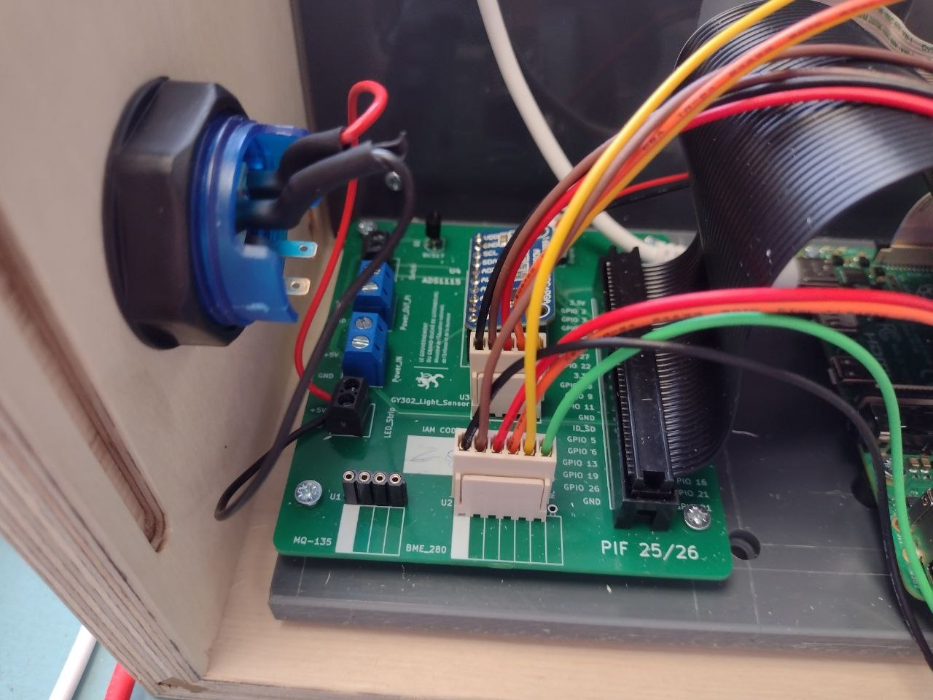
I have reattached the wires to the “switch” output later.

- Attaching the LED:
Then, to attach the LED, I took another pair of black and red wires and soldered them to the LED strip.
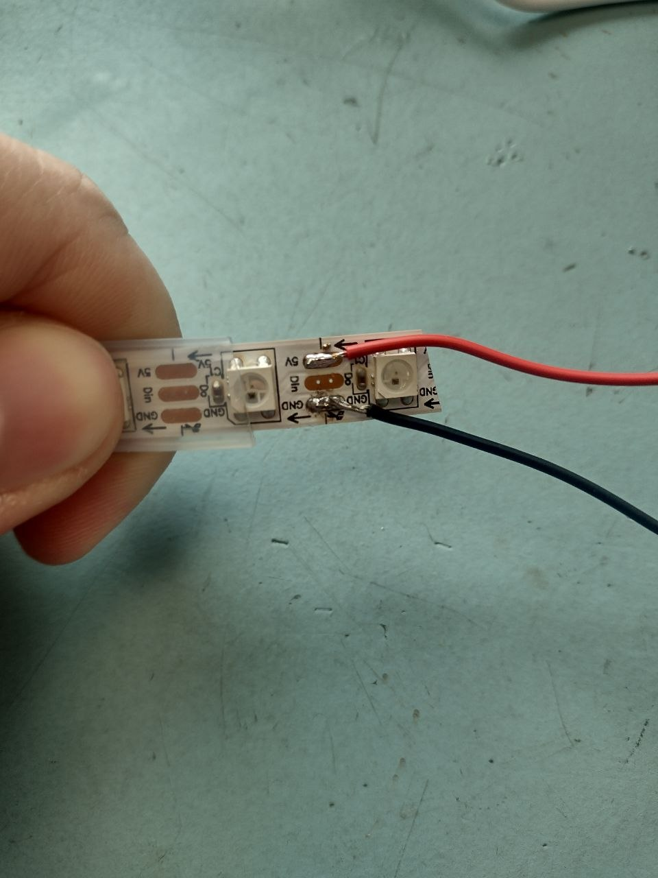
After that I have attached it to the “switch” output and taped the strip onto the box


- Results:
I have managed to successfully attach the LED strip and Button to the printed circuit board and finished the assembly of the raspberry pi station.


Userstory L6 – Backup Server
Table of Contents:
- Introduction
- Securing MYSQL credentials
- Creating backup script
- Scheduling crontab job
- Setting up FTP access
- Data restoration process
- Introduction
This documentation will provide necessary steps to ensure successful setup of the Backup Server running with Ubuntu Server OS. The first step in the beginning will be – installation of mysql-client and vsftpd. After this, the backupuser with home directory /backupuser needs to be created and structure created. Vsftpd will use /backupuser directory to provide backups. Cron is installed by default.

- Securing MYSQL credentials
To secure MYSQL credentials, I used command mysqld_config_editor with settings below:
After processing the command, it requests passwords and encrypts it, then it stores it in the ~/.mylogin.cnf file that will keep those credentials.
Testing it with mysql command to execute database:
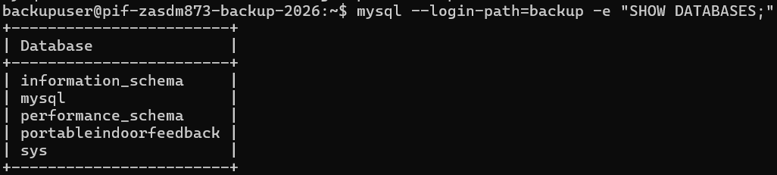
- Creating backup script:
To backup mysqldata I have used mysqldump command. To backup system data I have used sshpass to enter the system of my webserver and extract /var/www/ and /etc folders. At the bottom of the script is set automatic deletion of backups older than 7 days:
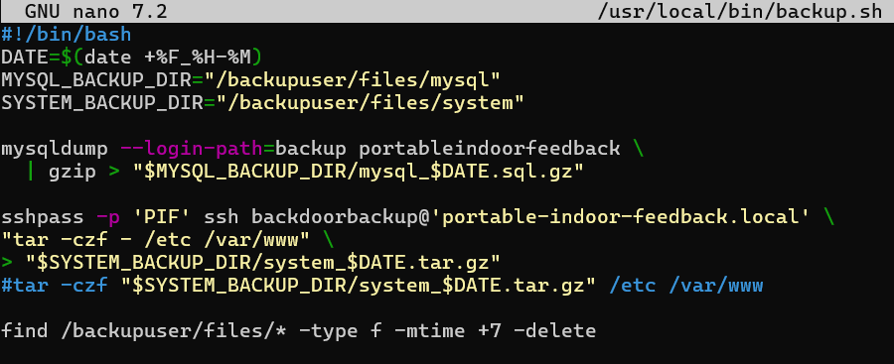

- Scheduling crontab job:
To schedule a crontab job I used crontab environment nano.
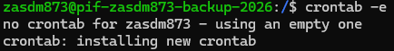
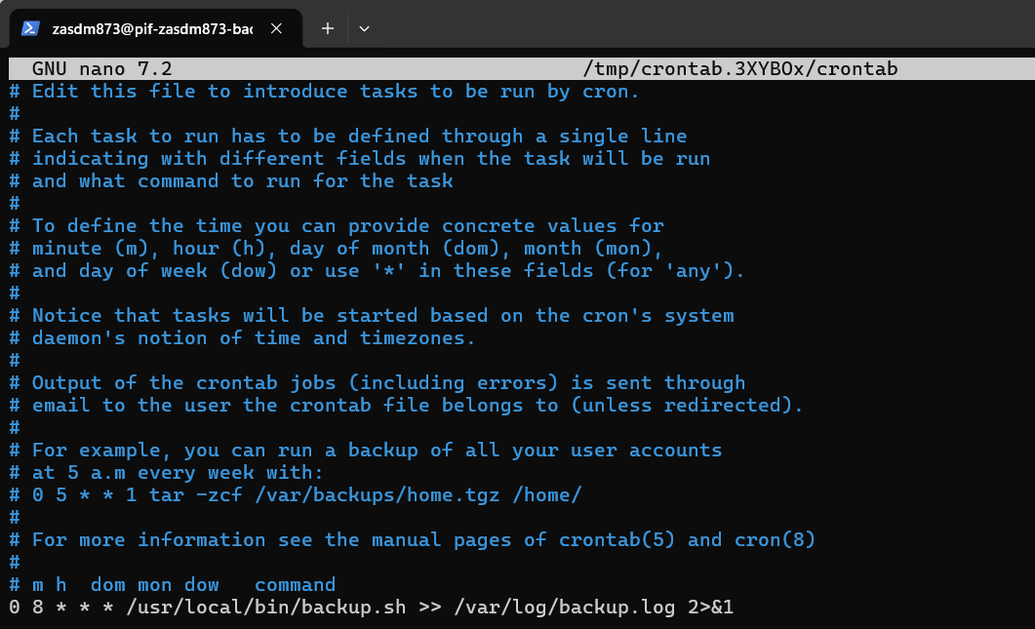
Then wrote this configuration. It activates every 8 hours /usr/bin/backup and directs it’s output to /var/log/backup.log ignoring error output.

- Setting up ftp access:
After installing vsftpd, I opened the config using nano
In the config file I have disabled anonymous ftp, allowed local enable, allowed write enable, allowed chroot_local_user
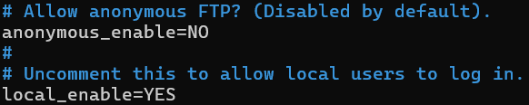
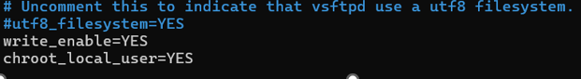

- Data restoration process:
To retrieve the data stored in the backup server, I need to use ftp command and connect to the backup ip address.
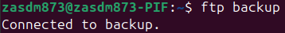
After that I need to login as a backup user.
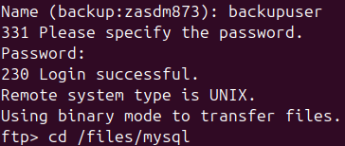
After that, I need to go to the directory where data is stored use get <name of file> command to retrieve the backup.
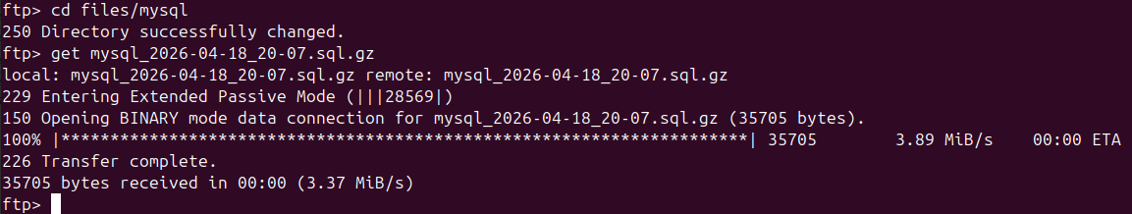
Transfer successful
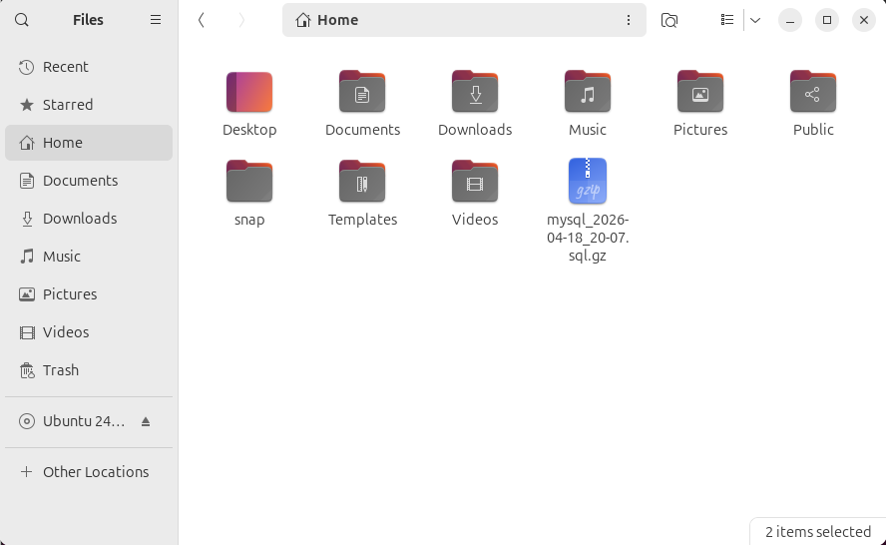
Now I will remove one of the entries in the database.
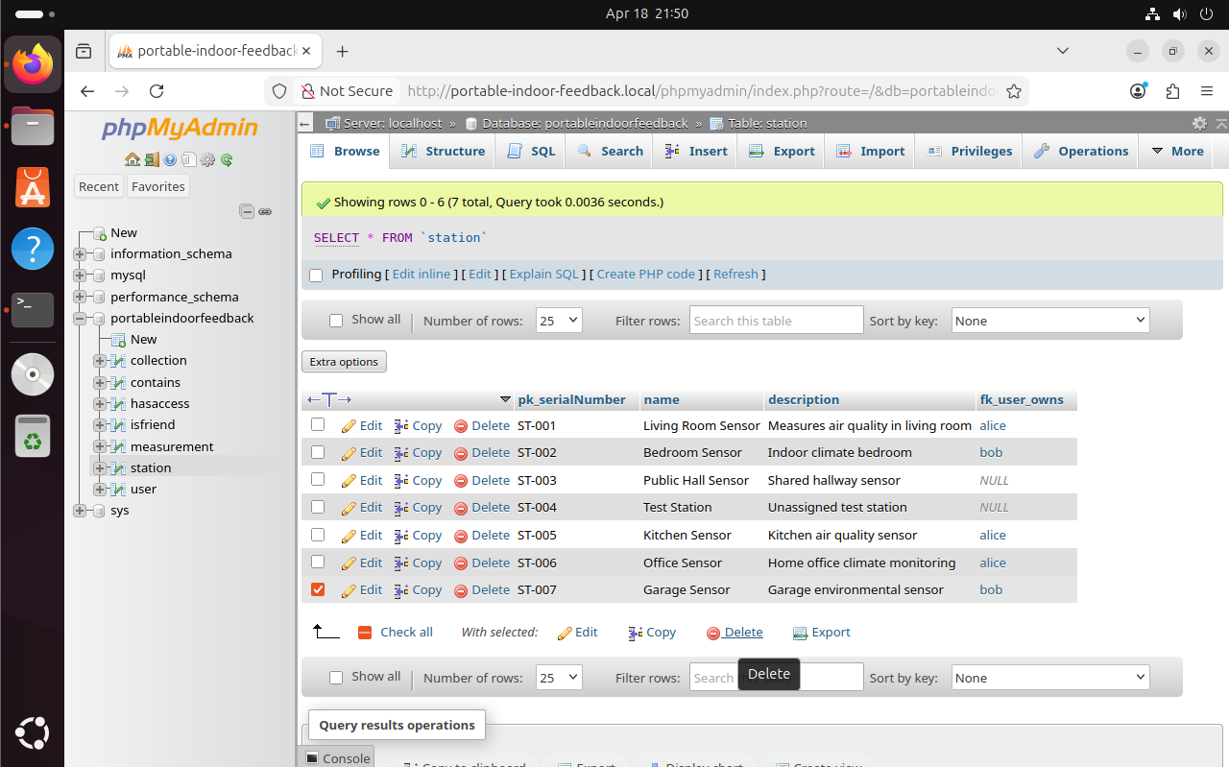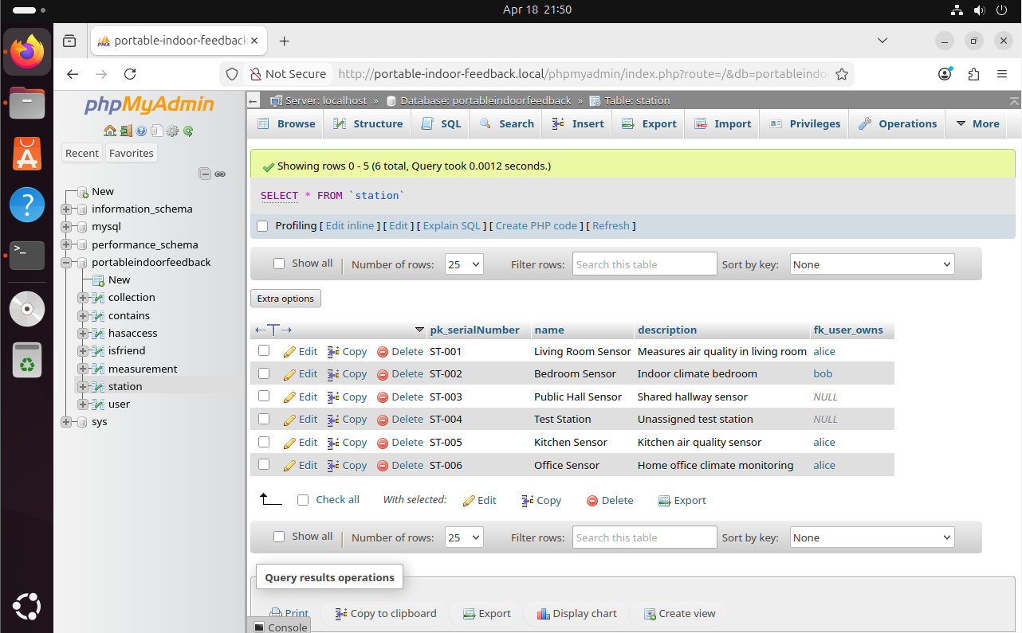
To execute the backup I am using gunzip and pipe(“|”) to login into the mysql and apply the sqldump data to the database.
After executing, refresh the page with the database and the backup is successful.
